FOSIP EXPT-1

Name:

UID:

Branch :

Batch:

Aim: The aim of this experiment is to study mathematical operations such as:

1. Linear Convolution,
2. Circular Convolution, and
3. Linear Convolution using Circular Convolution

**1. Linear Convolution**

Problem Definition: Find Linear Convolution of L point sequence x[n] and M point sequence h[n].

Experimentation

Case 1:

x[n] = {1, 1, 0, 1, 1}

h[n] = {1, -2, -3, 4}

Output

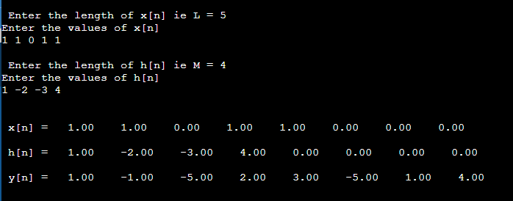

y[n] = {1, -1, -5, 2, 3, -5, 1, 4}

Analysis

Length of x[n] (L) = 5

Length of h[n] (M) = 4

Length of y[n] = L + M -1

= 5 + 4 - 1

= 9 -1

= 8

We conclude the following:

* Length of Linear Convolution output signal (y[n]) = Length of first input signal (x[n]) + Length of second input signal (h[n]) – 1
* Adding zeros at the end of the input signal does NOT change the output for Linear Convolution, i.e. Linear Convolution always gives a unique answer.
* In Linear convolution, if both the input signals are causal, then the resultant output signal is also causal.

**Circular Convolution**

Problem Definition: Find Circular Convolution of L point sequence x[n] and M point sequence h[n].

Experimentation

Case 1:

x[n] = {1, 1, 0, 1, 1}

h[n] = {1, -2, -3, 4}

Output

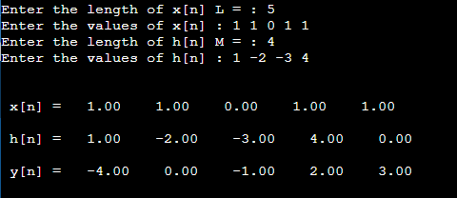

y[n] = {-4, 0, -1, 2, 3}

Analysis

Length of x[n] (L) = 5

Length of h[n] (M) = 4

To do circular convolution, it is necessary to have both input signals have equal length.

But the length of x[n] is 5 and h[n] is 4. So, we did zero padding for h[n] to increase its length from 4 to 5. We can see in the screenshot above that an extra 0 has been added at the end of h[n].

Length of y[n] = 5

Output for Linear convolution for the same input signals is:

y[n] = {1, -1, -5, **2, 3**, -5, 1, 4}

Output for Circular convolution for the same input signals is:

y[n] = {-4, 0, -1, **2, 3**}

We notice that 2,3 is common for both the output signals. And for the other values, we notice that the values have been aliased.

From the linear convolution output, we have added the values before and after 2,3 to get the required output for circular convolution.

Values before 2,3 = 1, -1, -5

Values after 2,3 = -5, 1, 4

If add the two values at same index, the final values that we get are

1 + (-5) = **- 4**

-1 + 1 = **0**

-5 + 4 = **- 1**

We can see that these values are, the first three values of the output for Circular Convolution

We conclude the following:

* Length of Linear Convolution output signal (y[n]) = Length of first input signal (x[n]) + Length of second input signal (h[n]) - 1
* Circular Convolution gives aliased output.

**Linear Convolution using Circular Convolution**

Problem Definition: Find Linear Convolution using Circular Convolution of L point sequence x[n] and M point sequence h[n].

Experimentation

Case 1: Length of input signals is Equal to the length of output signal of Simple Linear Convolution

x[n] = {1, 1, 0, 1, 1}

h[n] = {1, -2, -3, 4}

Theory

Original Length of x[n] (L) = 5

Original Length of h[n] (M) = 4

In Linear Convolution length of output signal y[n] = L + M -1 = 5 + 4 - 1 = 8

So if we want to use Linear Convolution using Circular Convolution, we will have to do zero padding for the input signals. We will have to add zeros to the end of the signal such that the length of both the input signals will be equal to the length of the output signal in Linear Convolution.

Since length of x[n] = 5, to make its length = 8, we will pad signal x[n] with 8-5 = 3 zeros.

Similarly length of h[n] = 4, to make its length = 8, we will pad signal x[n] with 8-4 = 4 zeros.

Therefore final x[n] = [1, 1, 0, 1, 1, 0, 0, 0]

Therefore final h[n] = [1, -2, -3, -4, 0, 0, 0, 0]

And,

L = M = 8

Output

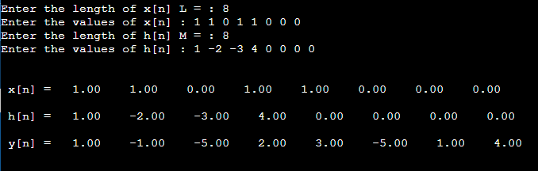

y[n] = {1, -1, -5, 2, 3, -5, 1, 4}

Case 2: Length of input signals is GREATER than the length of output signal of Simple Linear Convolution

For Case 2, we will add two extra zeros to the already padded input signals to get length greater than the length of the output signal of Linear Convolution.

Output

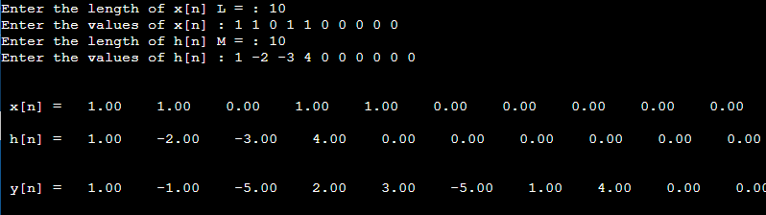

y[n] = {1, -1, -5, 2, 3, -5, 1, 4, 0, 0}

Analysis

Final Length of x[n] (L) = 8

Final Length of h[n] (M) = 8

Final Length of y[n] = 8

In Circular Convolution length of output signal y[n] = L = M = 8

We can see that this y[n] is the same as the one that we got by doing Linear Convolution in the first case.

We will get the same y[n] if we add extra zeros to make the length greater than L+ M -1 of original signals = 8. So if we make length of x[n] = 10 and Length of h[n] = 10, we will get the same output signal y[n] with 2 extra zeroes at the end.

We conclude the following:

* We will get correct output only when length of input signals with padding is greater than or equal to the length of output signal of simple Linear Convolution
* Length of output signal (y[n]) >= Original Length of first input signal (x[n]) + Original Length of second input signal (h[n]) – 1

**Conclusion :**

1.

2.

3.